Exp.No:27
27. Do Cropping, Copying and pasting image inside another image using OpenCV.

Aim:
To perform cropping, copying, and pasting on an image using OpenCV.
Procedure:
- Read the input image (Shinchan.jpg).
- Crop a selected portion of the image.
- Copy the cropped region.
- Paste the copied region into another location in the same image.
- Resize the image for medium-size display.
- Display the original and modified images.
- Save the output image.
Program:
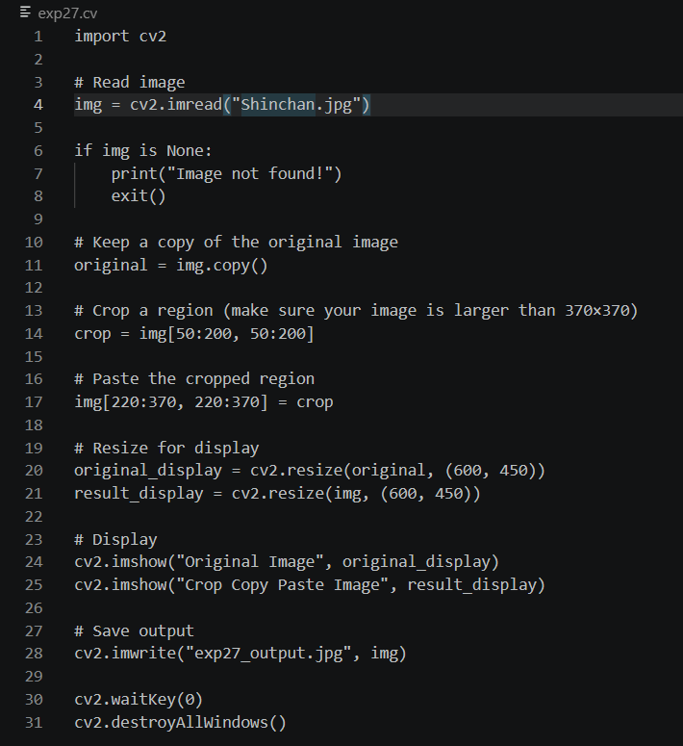
Input:
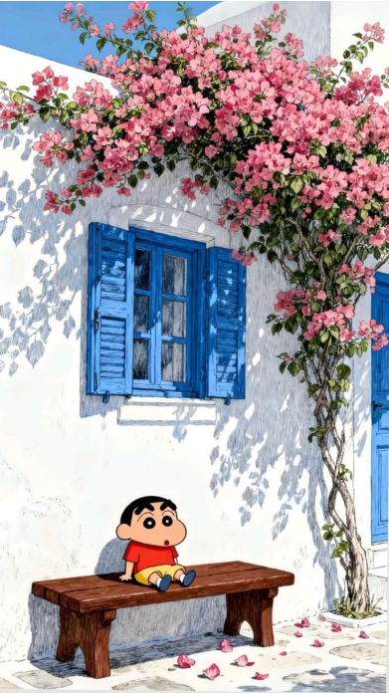

Output:
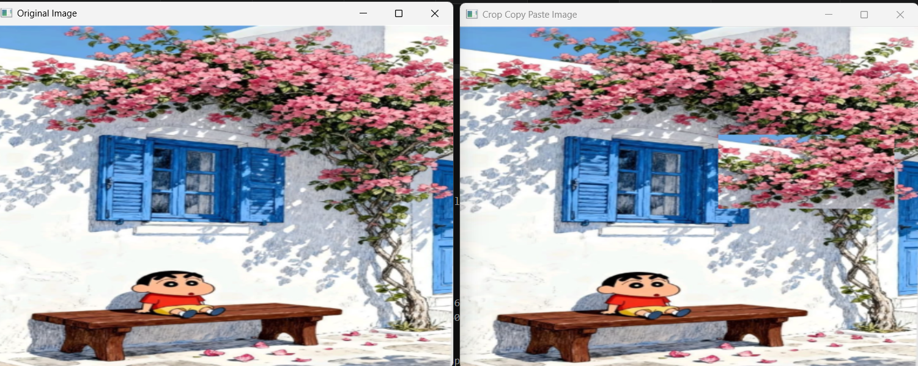

Result:
The image was successfully cropped, copied, and pasted using OpenCV. The modified image was displayed and saved successfully.

